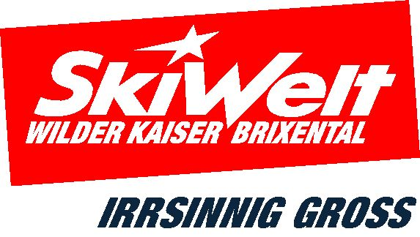
PRESS RELEASE | 2016-06-01

Family Paradise in the Mountains – unbeatable summer holiday fun!
Many new attractions at the Wilder Kaiser – Brixental theme parks
Climbing, playing, exploring, researching:
Every day a new adventure!

Summer holidays with the whole family, endless hiking experiences for big and small, plenty of variety for active sports enthusiasts – all this in the unique mountain landscape of the Tyrolean Alps. At the mountain theme parks of the Wilder Kaiser – Brixental Cable Car Company, a new adventure awaits you every day! That’s what makes summer holidays so much fun here!

Take a cable car up the mountain and dive into the exciting theme parks of Wilder Kaiser – Brixental. No fewer than 13 modern cable cars, most of them suitable for buggies and wheelchairs, provide the perfect introduction to Austria’s largest mountain experience: six mountain theme parks for young and old, more than 700 kilometres of well-maintained hiking trails, rustic huts, hearty home-cooked meals and a unique panoramic view of over 70 three-thousanders.

Lots new at the Wilder Kaiser – Brixental theme parks

A brand new adventure area has been created at Alpinolino Westendorf - the “wood(worm) trail”, which runs from the middle to the bottom lift station, has been upgraded and a few new exciting stops have been added. Eager Alpine detectives can look forward to the new puzzles at the Alpinolino Riddle Rally!

New attractions can also be found at Hexenwasser Söll. There are unique hiking experiences for everyone, with families, seniors and less experienced hikers benefiting in particular from the new Keat summer lift in Söll, which provides convenient transportation for hikers up to 1,500 meters: the motto being “float easily up to the Hohe Salve”. Once at the top station of the Keat lift, you have no fewer than ten gentle, idyllic hiking trails to choose from – a particularly refreshing treat is the “mountain spring” walking trail around the Hohe Salve, with points of interest on the subject of spring water and alpine pastures. Everything revolves around spring water at the new stations of the “Blaues Wunder” (blue wonder) at the Hexenwasser theme park: taste, feel and experience the coolness – a refreshing encounter with the wonderful world of water. And to relax after a “bewitching” day, the Bäck cafè & bar awaits with a new experience terrace right by the bottom lift station.

Plenty of news from Ellmi’s ZauberWelt too: the new 10-seater gondola with middle station goes conveniently up to 1,500 metres, where many new activities await adventurers young and old: Ellmi's mini climbing park has been extended and the new summer tubing track promises fast-paced fun for intrepid mountaineers. Even the range of services has been improved: the visitor orientation map has been completely redesigned and the Ellmi Shop, in the tourist information centre on the Hartkaiser, has everything to do with the magical Zauberwelt park.

Six Mountain Theme Parks: a new adventure every day!

The six unique mountain theme parks of the Wilder Kaiser – Brixental Cable Car Company provide tailor-made offers for families with children. Lovers of variety can plunge into a fresh new adventure every day: the unique watery paradise, “Hexenwasser” in Hochsöll, Tyrol’s best viewing mountain, the Hohe Salve with sun dial path, the giant wind harp and Austria’s highest pilgrimage church at 1,829 metres above sea level, the Alpine discovery park “Alpinolino” in Westendorf, the informative natural paradise around mysterious Lake Filzalm in Hochbrixen, the KaiserWelt Scheffau with games, fun and adventure for the little ones and relaxation for the grown-ups or Ellmi’s ZauberWelt on the Hartkaiser in Ellmau, the mystical fantasy world home to fairies, goblins, forest spirits and “Ellmi” the magic frog.
6 mountain theme parks, 13 lifts, 700 kilometres of hiking, 1 ticket!

The Hiking Experience Pass is the perfect all-round package for your summer in the mountains: just one ticket gives you unlimited use of all 13 lifts in Austria’s largest summer adventure area – with all six mountain theme parks for families, plus the “KaiserJet” bus to all the lifts and swimming facilities between Going, Ellmau, Scheffau and Söll. And one more thing, with the hiking pass (guest card reductions!) you enjoy discounts with 23 Bonus Partners in the region: leisure facilities, pools, attractions and activities with up to 50% off the normal price.

Jump in & discover: Austria’s biggest mountain experience awaits! Wilder Kaiser – Brixental cable cars and lifts offer 6 summer theme parks (Lake Filzalm Brixen im Thale, Ellmi’s ZauberWelt Ellmau, Hexenwasser Söll, Hohe Salve Hopfgarten/Söll, KaiserWelt Scheffau, Alpinolino Westendorf & Natural Experience Kaisergebirge), easily accessible via 13 modern lifts. Most of the facilities are suitable for buggies and wheelchairs. The “KaiserJet”: the free bus to the lifts and bathing facilities between Going, Ellmau, Scheffau and Söll. Special discounts with 23 Bonus Partners across Tyrol.

INFORMATION SkiWelt Wilder Kaiser - Brixental Marketing GmbH
A – 6306 Söll | Tel: +43 5333 - 400 | Email: office@skiwelt.at
www.skiwelt.at
ENQUIRIES: SkiWelt press team (presse@skiwelt.at)

